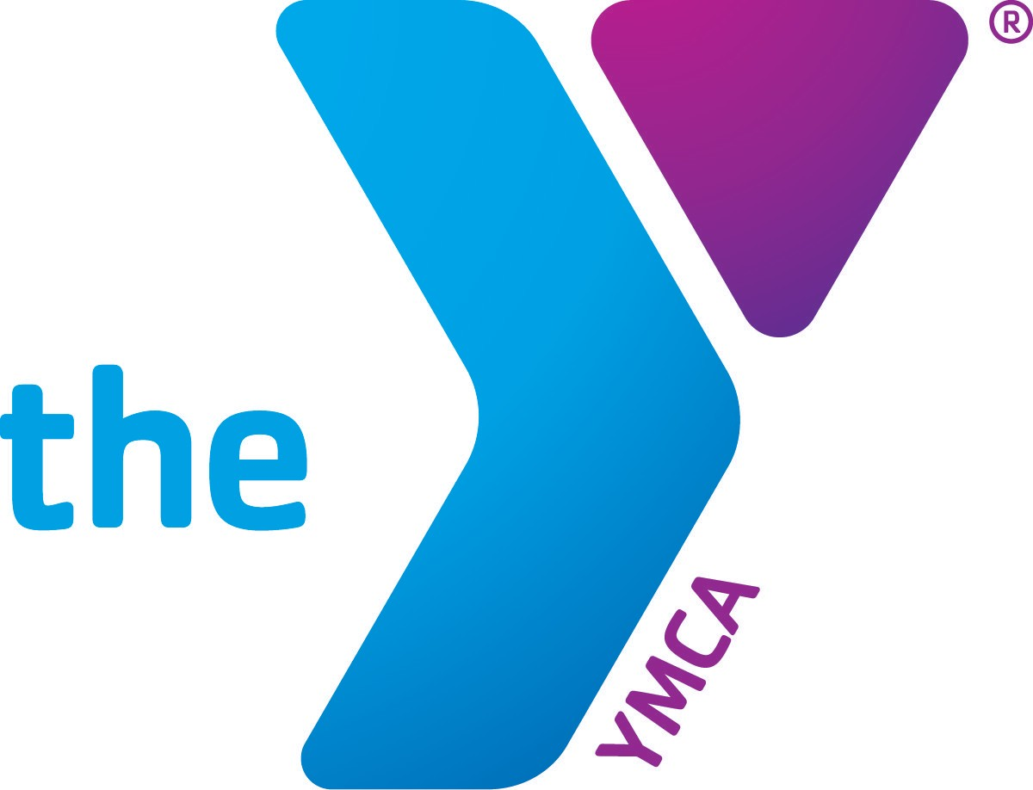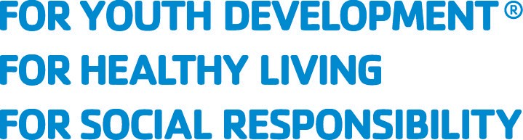

FAQs

What IS Health and Well-being coaching?
Coaching refers to a partnership between a client and his/her coach in which they engage in (one or more) thought-provoking and creative conversations. Through the coach’s deep listening and insightful questioning, the client is supported by the coach in getting clear about their goals and inspired to reach them.
Health coaching focuses on helping the client set and achieve goals related to healthy weight management, elevating their physical fitness routine, making mindful nutrition choices, creating healthy sleep routines, and learning how to incorporate self-care into your daily routine.
Life coaching focuses on helping the client set and achieve goals related to personal growth, career, finances, recreation, self-care, spirituality, romance, relationships, moving through change, or overall life satisfaction.

Why does this work so well?
Coaching philosophy holds that each person has the capacity for wholeness already within themselves. When a person is deeply heard in a safe and supportive space, they experience what they truly want for themselves and begin to identify the inner and outer resources to grow towards that wholeness.

What can I expect to happen in these sessions?
Sessions usually last anywhere from 30-60 minutes. You and your coach will have an initial meeting in which together you determine if you two are a good fit. If so, you explore your possible goals for coaching, how many sessions you may need and how often you will meet.
Each subsequent, individual session will center on a topic related to your goal and will have a desired outcome decided on by you. You will have identified some next steps toward your overall goal and a way to be accountable for taking those steps before the next session.

How do I know that I’m a good candidate for coaching?
You’re already asking an important question!

Here are some more that might help you decide:
Are you wanting to make changes towards a healthier/happier you?
Are you ready to engage in personal growth?
Are you willing to be curious about what you most want in your health and your life right now?
Are you willing to share about yourself with a trusted coach?
Are you willing to look at what might stand in the way of what you want for yourself?
Are you willing to take some action, however small, towards what you want?

If your answer is anything but an absolute ‘No!” and you can find an adventurous spirit in you, you are likely a very good candidate!

WHATCOM FAMILY YMCA
1256 N State Street, Bellingham WA 98225 P 360 733 8630 F 360 734 8406 WWW.WHATCOMYMCA.ORG

